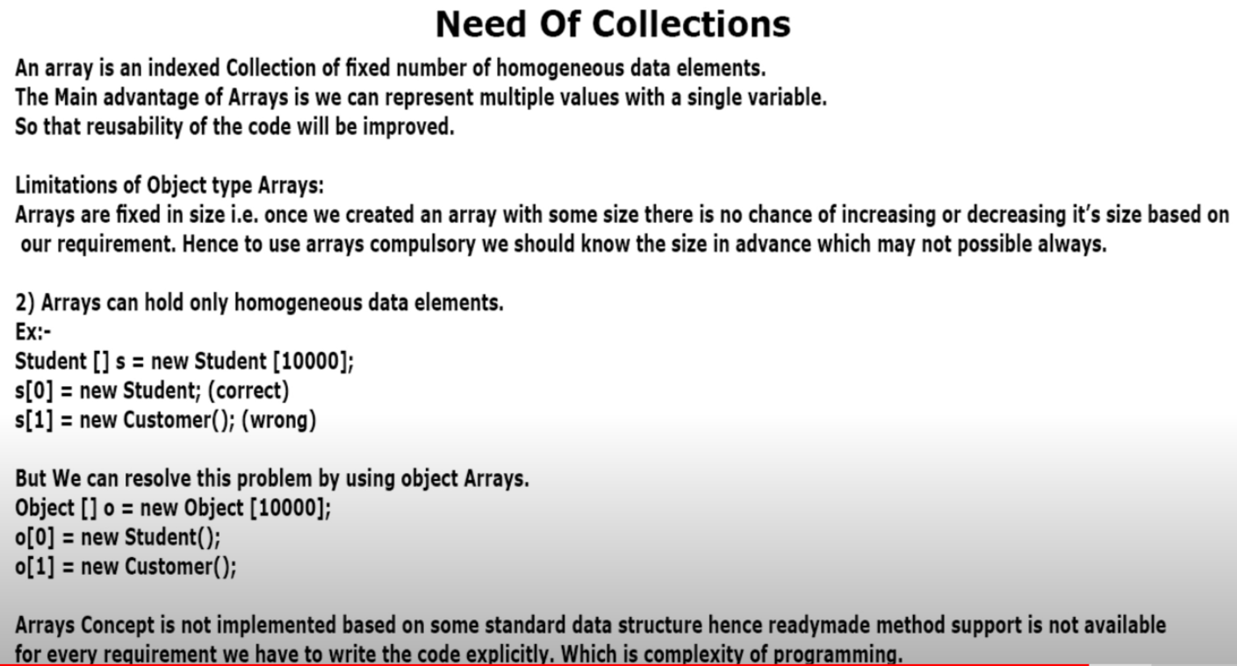

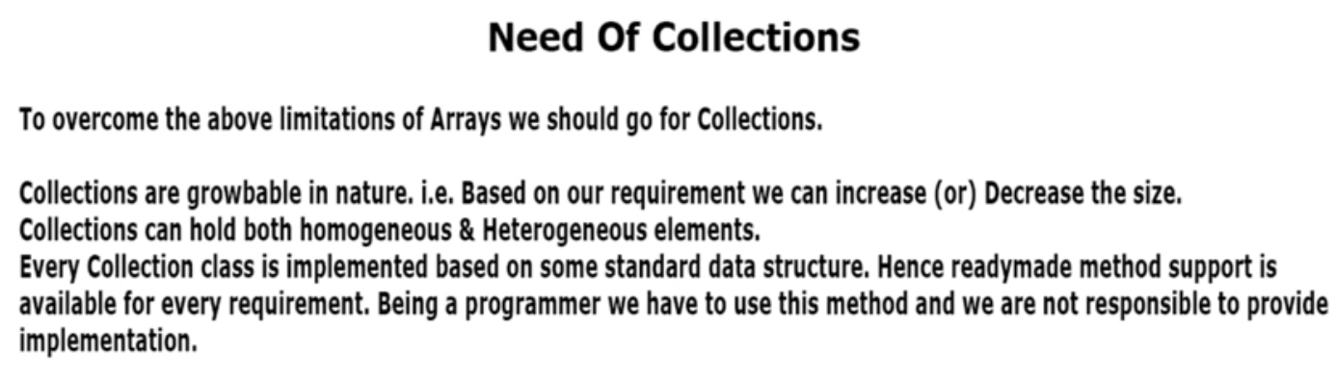

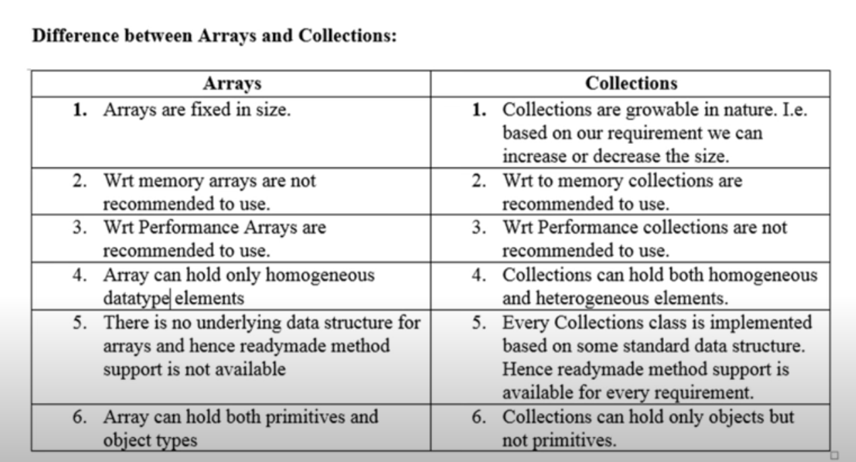



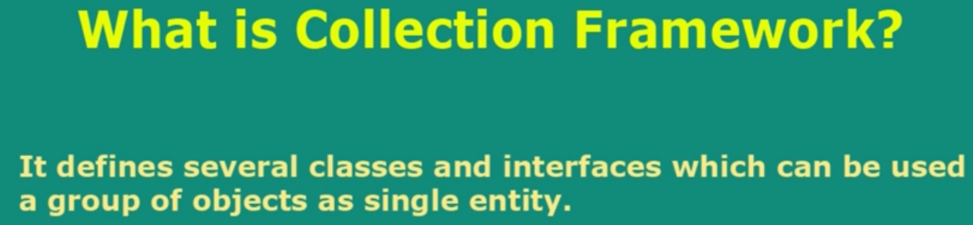

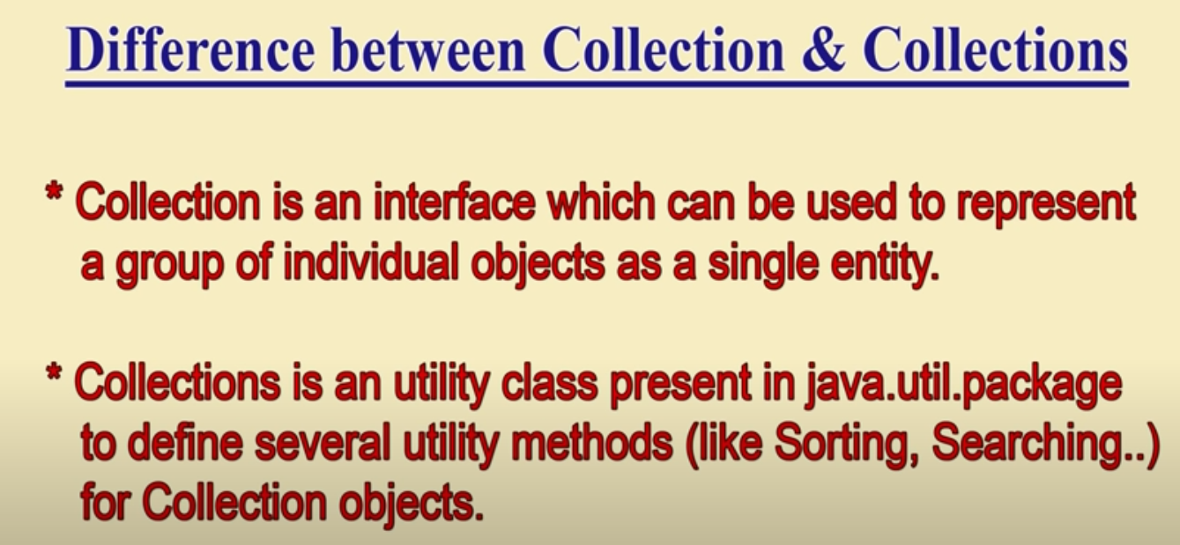

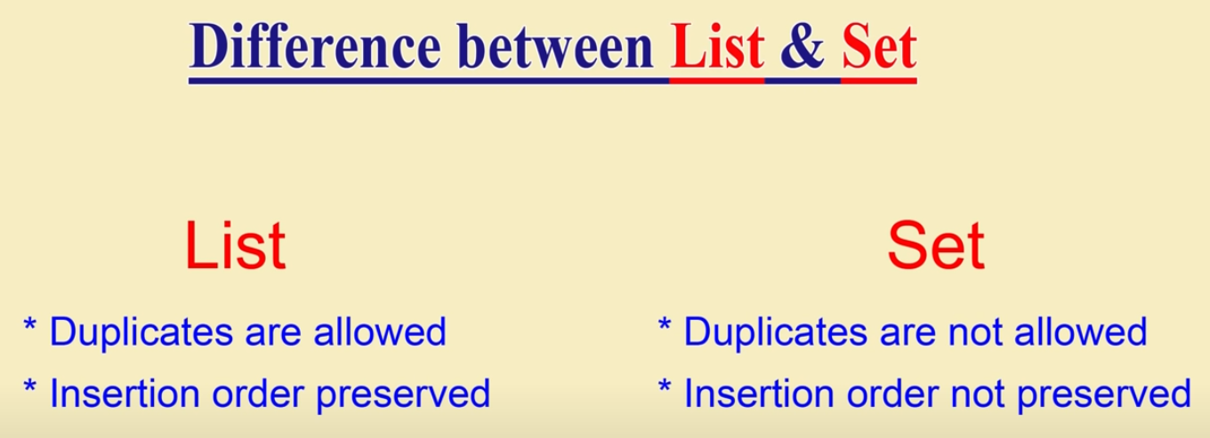

**Overview of collection framework:** There is two main interfaces

1. **Collection**: This is the generally considered the root interface of collection framework (even though technically not correct). It contains 3 main interfaces
   1. **List**: If we want duplicate data and sorting order preserved, we can use this. **ArrayList** and **LinkedList** are two classes that implement this interface. Vector and its subclass Stack are legacy classes
   2. **Set:** If we don’t want duplicates then this data structure we can use.
      1. In case we want sorting then there is **SortedList** interface
      2. **NavigableSet** is when we want navigation front and back etc**.**
   3. **Queue:** It is a FIFO data structure.
2. **Map:** When we want to store a key-value pair, we can use this.



